MSD IT Services

Making a secure Remote Desktop Connection to your Work Windows 10 Desktop PC Using the MSD ITS VPN Service and a Windows, Mac OS X, or Linux Remote Desktop

MSD IT Services
ithelp@medsci.ox.ac.uk
11/03/2020

Contents

Introduction 1
Background 1
Connections covered in this document. 1
Brief overview of the procedure 1
Before you begin - Requirements for all 3 types of connections mentioned above 1
1. Enabling Remote Desktop Connection on your Work Windows PC 3
PART A: Enabling Remote Desktop Access 3
PART B: Find the IP address of your work PC 5
2. Remote/Home PC set up 8
Part A: Setting up the VPN software 8
Part B: Setting up the Remote Desktop software and connecting 10
Part C: Disconnecting from your Work Desktop PC 15
3. Remote/Home Apple Mac OS X PC set up 16
Part A: Setting up the VPN software 16
Part B: Setting up the Remote Desktop software and connecting 19
Part C: Disconnecting from your Work Desktop PC 20
4. Ubuntu 14.04 Home PC set up 21
Part A: Setting up the VPN software 21
(i) Native VPN Client 21
(ii) The Cisco AnyConnect Secure Mobility Client 24
Part B: Setting up the Remote Desktop software and connecting 26
Part C: Disconnecting from your Work Desktop PC 30

Introduction

Background

Medical Sciences Division IT Services (MSD IT) implements a security policy to protect the IT infrastructure of the University's Medical Sciences Division from unauthorised use and intrusion. As part of the security measures, MSD IT operates network filters, which block access to the MSD IT network on certain ports.
Those wishing to access their office (or lab) computer can do so via ‘Windows Remote Desktop’, having first established a connection to MSD IT’s Virtual Private Network (VPN) service.

Connections covered in this document.

- Remote Windows PC to a Work Desktop Windows
- Remote Macintosh PC to a Work Desktop Windows
- Remote Ubuntu Linux PC to a Work Desktop Windows

Brief overview of the procedure

The procedure to connect to your Work Desktop PC from your Home PC requires the following steps; they are, after connecting your Home PC to your own internet connection:
- Make a connection to your local (home) network

- Make a Virtual Private Network (VPN) to the MSD IT Services VPN service.

- Make a Remote Desktop Protocol (RDP) connection to your Work Desktop PC.

Before you begin - Requirements for all 3 types of connections mentioned above

These requirements are needed BEFORE you attempt to access your Work Desktop PC from your Home machine. You will need:
- An MSD IT network account (aka ‘OES/Novell login account’)

- A Virtual Private Network client for your local (Home) operating system (recommended client software):

- Windows PCs: The University of Oxford’s IT Services Virtual Private Network (Cisco AnyConnect VPN) client.

- Macintosh PCs: The Apple OS X native VPN client

- Ubuntu PCs: Either the University of Oxford’s IT Services Virtual Private Network (Cisco AnyConnect VPN) client, or the native VPN client.

- You will also need to know the IP address of your Work PC; Please see Section 1, part B. If you have any problems, please contact MSD IT Services
- Your work computer must be switched on

Please Note: The following step MUST be completed on your Work PC BEFORE you attempt to connect to it from your Home PC.

1. Enabling Remote Desktop Connection on your Work Windows PC

PART A: Enabling Remote Desktop Access

- Right click on the Windows 10 Start icon

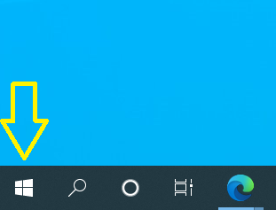

- Select System:
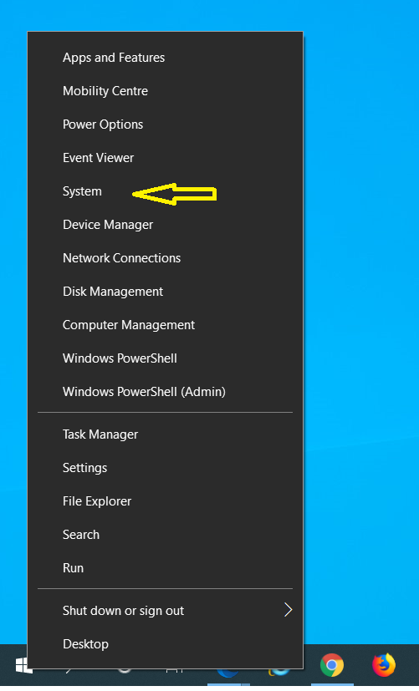

- ‘Remote Desktop’ from the left hand column & set ‘Enable Remote Desktop’ on:
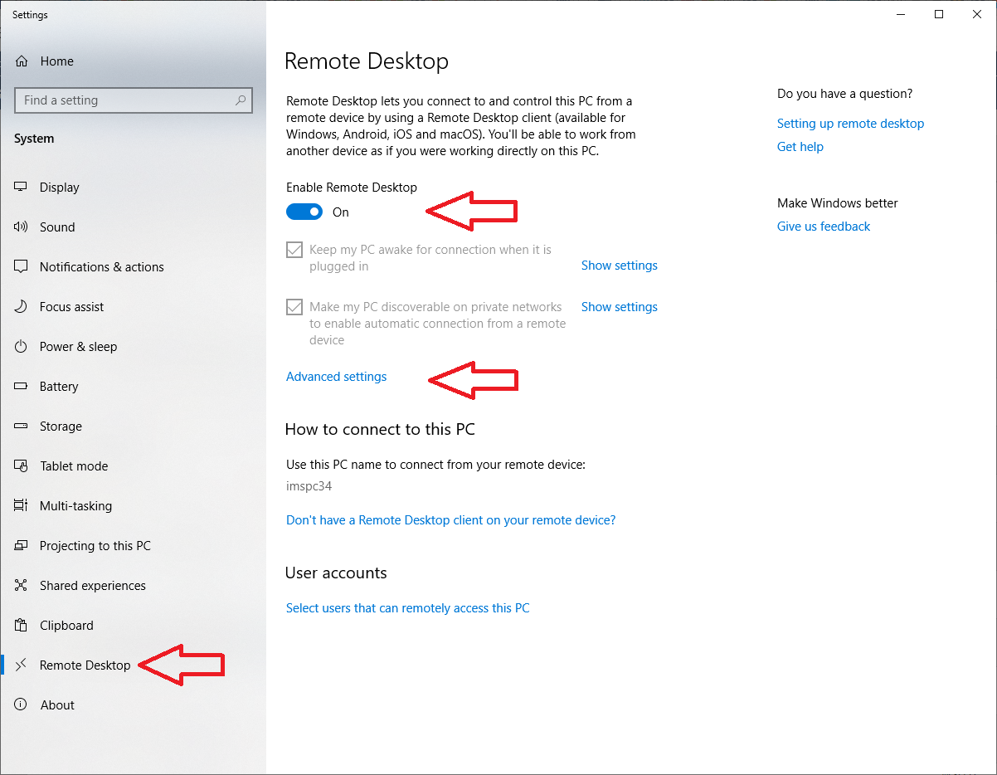
- Click on ‘Advanced settings’ & tick the box ‘Requires computers to use Network Level Authentication…..’
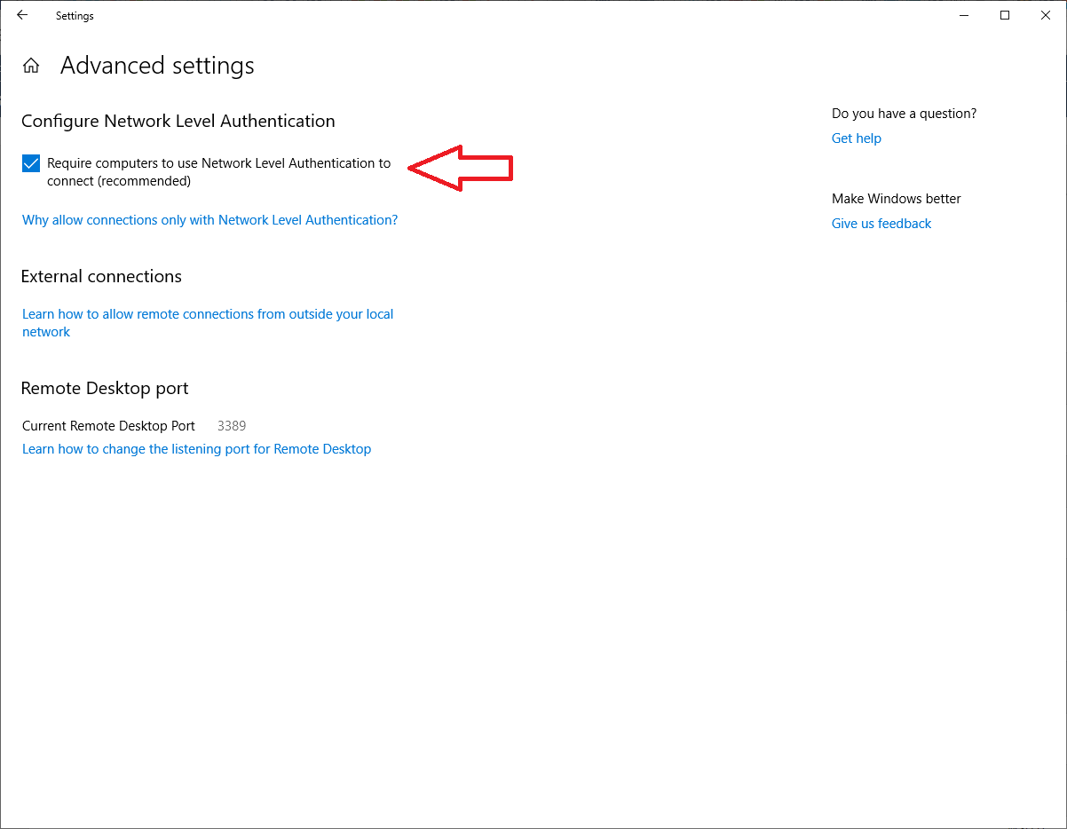

PART B: Find the IP address of your work PC

- The easiest way to find your public IP address is to use either the Google or Bing search engines. If your default search engine is either of these, type “What’s my IP address” in to your search bar: You should get an answer like this:

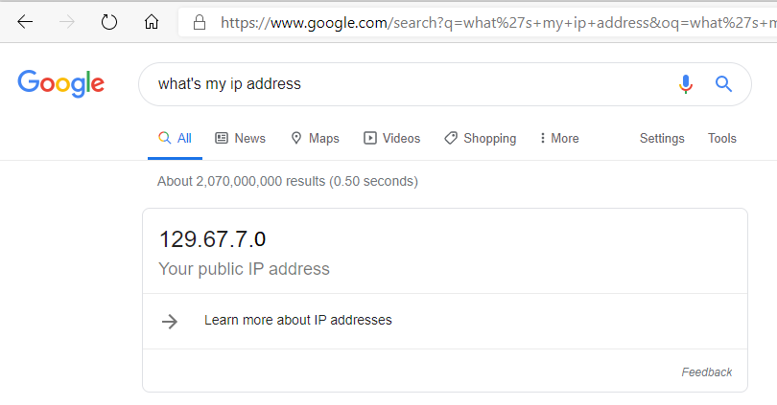

Alternatively, you will need to check the Network Connection settings:
  - You need to record the IP address of your PC for use when making the remote connection. First right click on the Windows Start icon & select Network Connections
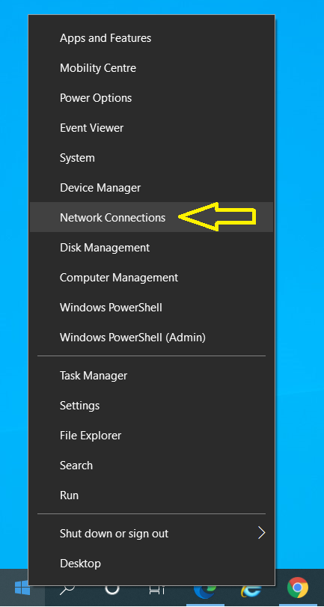

  - This opens the Network & Internet settings & select Ethernet:
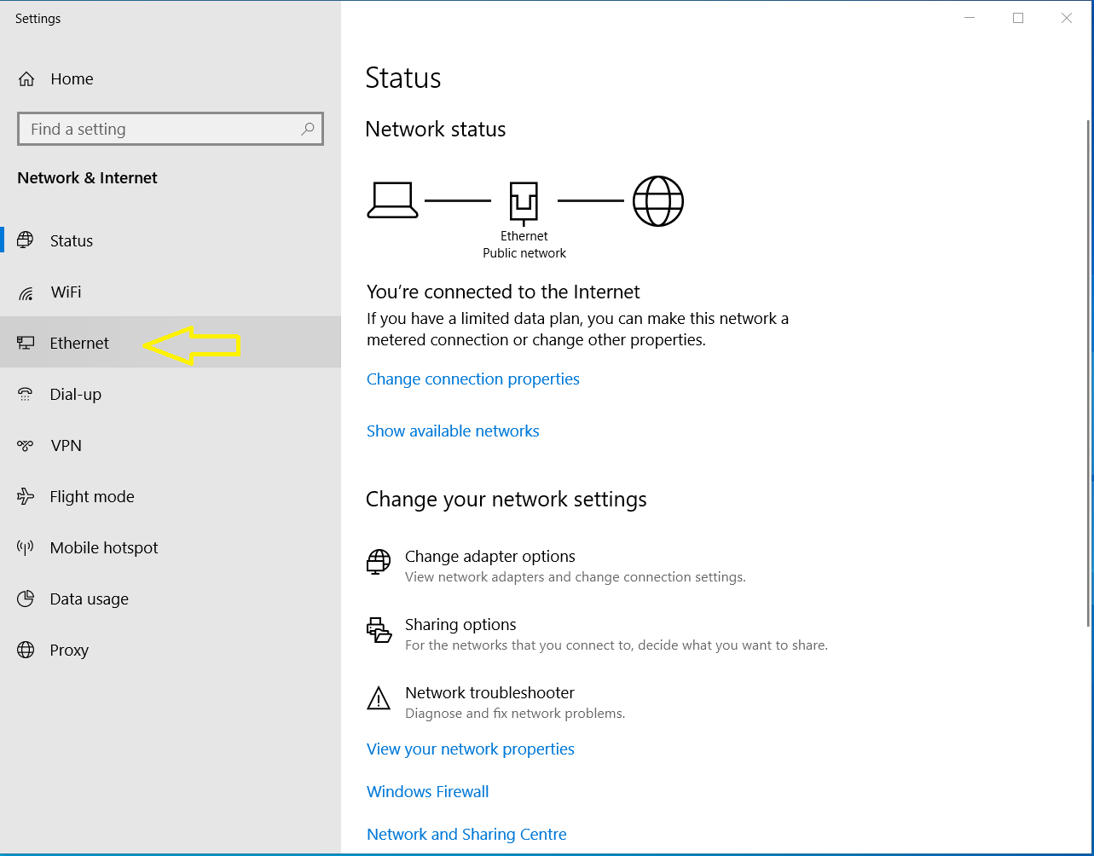

  - Then select the Network icon in the right hand panel:
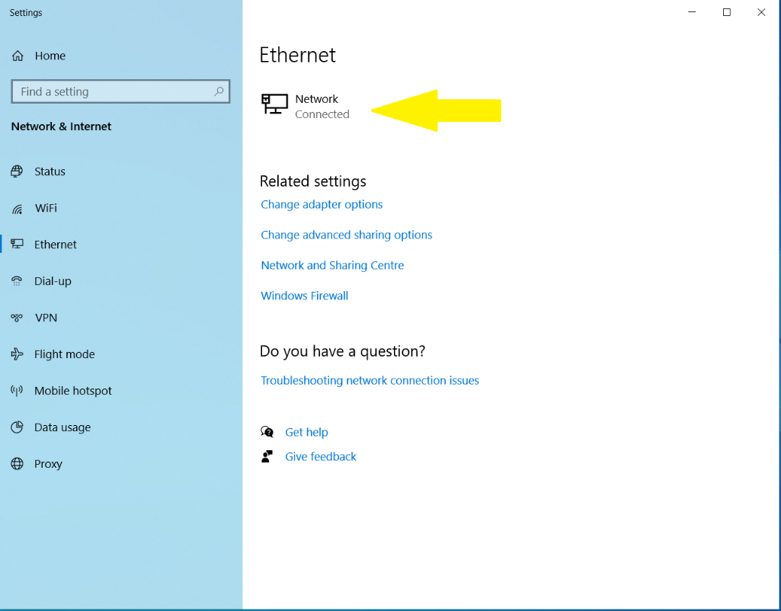

  - Scroll down and record the IPv4 address:

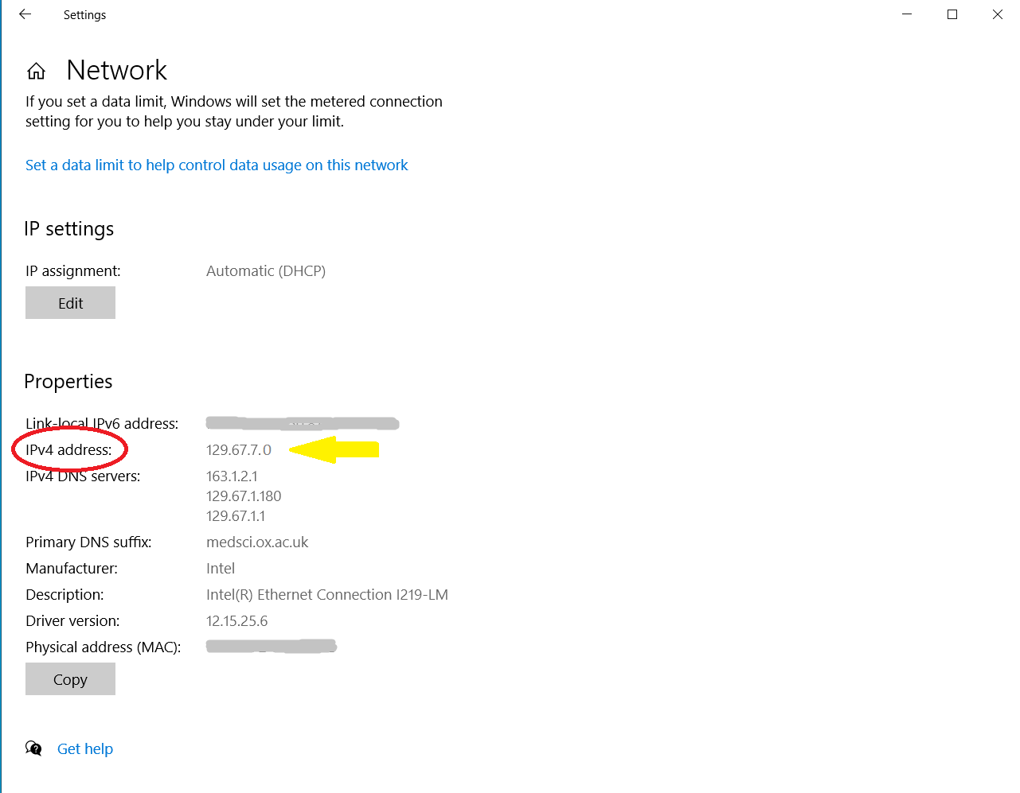

  - Close the Settings panel & your work PC is now configured for Remote Desktop Access.

The next section deals with configuring your Home or remote PC to access your Work PC via the MSD IT VPN service.

2. Remote/Home PC set up

Part A: Setting up the VPN software

- If you have not already done so, download and install the Cisco AnyConnect VPN Client from the University of Oxford IT Services Registration Pages at:

https://register.ox.ac.uk
Log in with your Single Sign On (SSO) username/password and select ‘Software’, then ‘VPN Client’ from the links provided. Download the Windows 10 client and install it; this client is preconfigured for use with the University of Oxford VPN Service but you must use the MSD IT VPN service for RDP sessions.
- Once installed, start the Cisco AnyConnect VPN Client:

Start> Cisco > Cisco AnyConnect Secure Mobility Client
- Make sure the ‘Ready to connect’ box contains:

vpn.medsci.ox.ac.uk
…as shown:
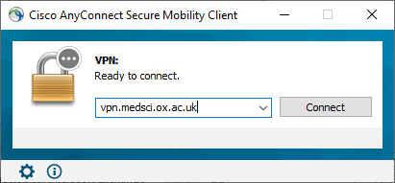
…then click on ‘Connect’.

- Following your first successful connection the login panel will look like this:
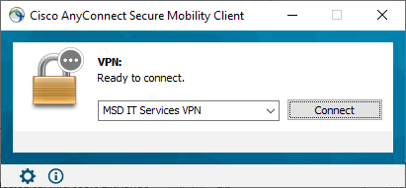
- There is no need to over type the address.

- Next enter your MSD IT network/OES/Novell account details in the ‘Username:’ and ‘ Password:’ boxes provided:

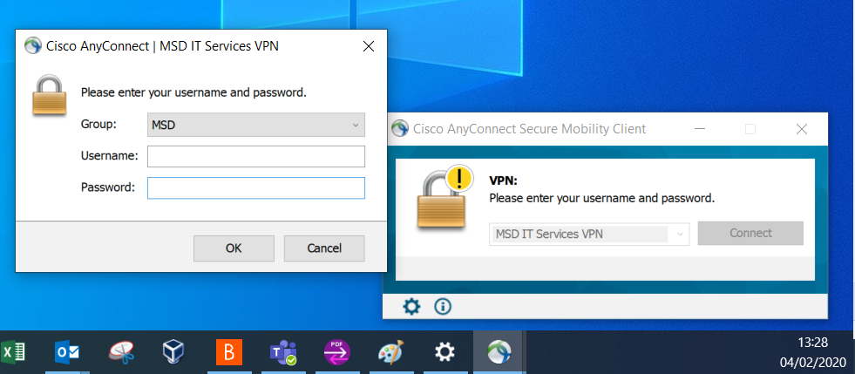
…then click ‘OK’
Once a successful connection has been made, the VPN Client will minimise itself to the System Tray (bottom right hand corner of the desktop.)

Part B: Setting up the Remote Desktop software and connecting
  - From the Start menu, find Windows Accessories and then Remote Desktop Connection:
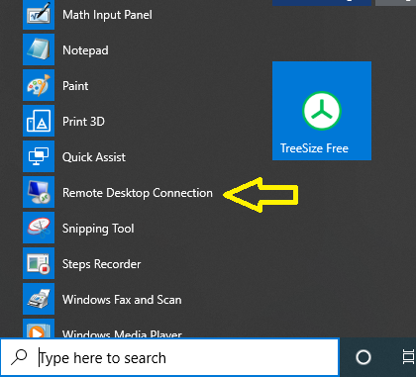

Tip: You may like to pin this to your task bar, by a right click on the item & then select more & then Pin to task bar:
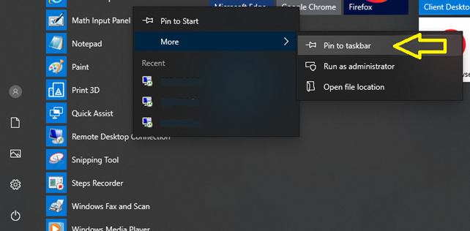

  - In the pop up panel select: ‘Show Options’ in the bottom left hand corner
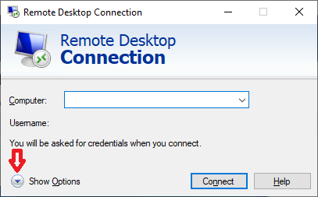

  - Type in the IP address of your work computer (e.g. ‘129.67.155.0’) from Section 1 and your MSD Network username, then click Connect

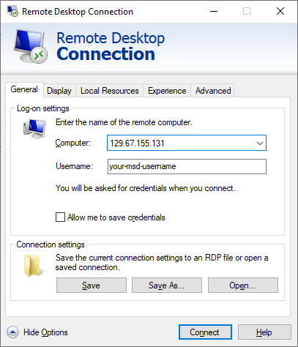

  - You should then receive a message like this:

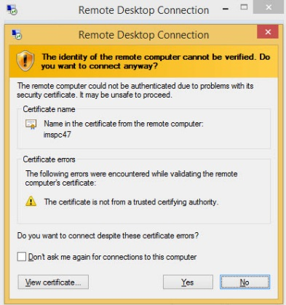
  - Tick the box ‘Don’t ask me for connections to this computer’ and then click ‘Yes’.
  - If you left your username logged in to your work PC, you will then be presented with the following:

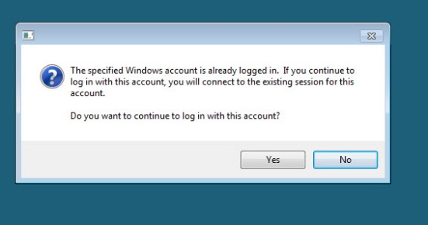
  - Again select ‘Yes’ and you will finally be connected to your Work PC:

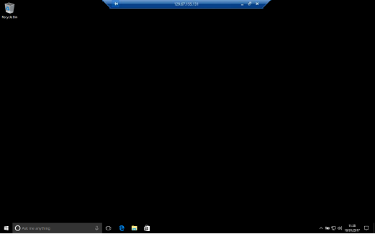
  - If you hadn’t left your remote computer logged in and you need access to your network drives, you can now log into the network
  - If you see a large letter ‘N’ in the system tray:
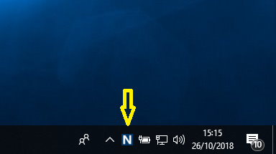

- If you don’t see the ‘N’ in the system tray, click on the caret

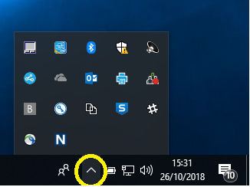

- Then right click-on the ‘N’ & click on ‘OES Login…’

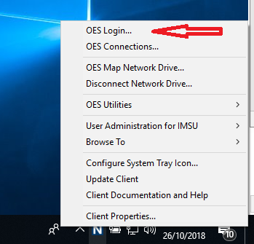
- You can then log in to see your network drive:

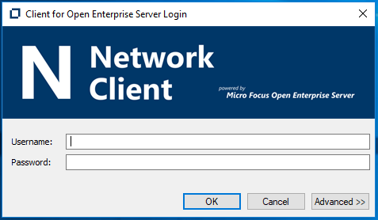

Part C: Disconnecting from your Work Desktop PC

- Close down the RDC session (do not ‘Shutdown’ or ‘Log off’ from your Work PC - unless this is actually what you want to do), simply click on the ‘X’ on the top central panel of the RDP Screen, titled with your Work PC’s IP address, e.g.:

- Now close the VPN Session; in the System tray locate the Cisco AnyConnect icon, right click on it and select ‘VPN Disconnect’:

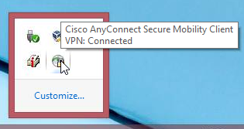

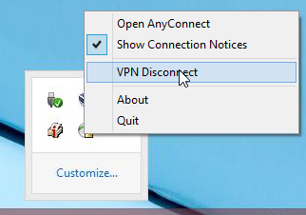
This will end your VPN session.

3. Remote/Home Apple Mac OS X PC set up

Part A: Setting up the VPN software

- To configure the Apple OS X native VPN client, from System Preferences (either from the Dock or the Apple Menu) select Network:

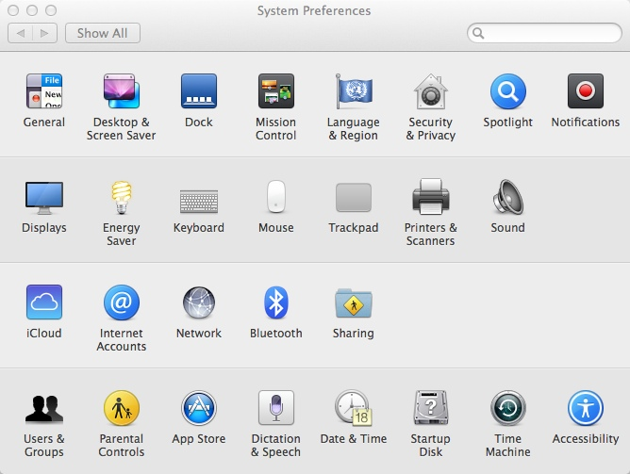

- In the Network Control Panel click on the ‘‘ symbol in the lower left hand corner to add a new network connection:

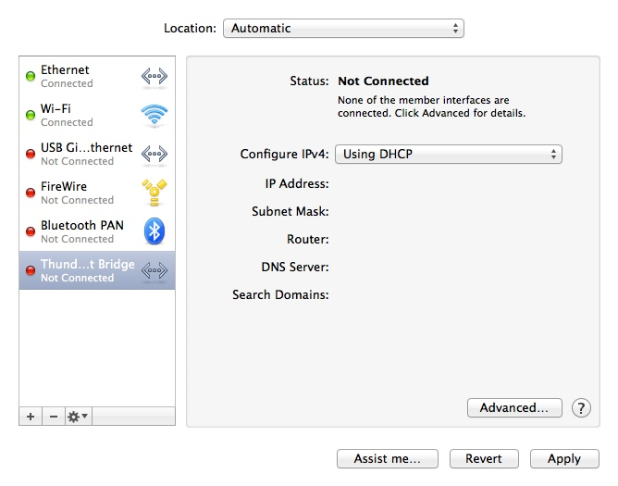

- From the pull down ‘Interface:’ list, select VPN:

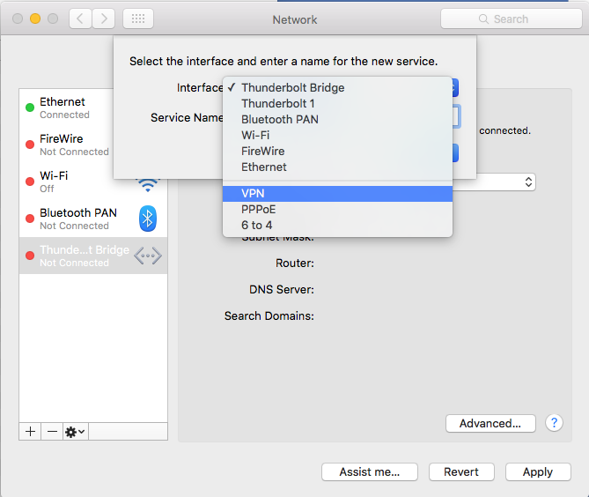
- Then from the ‘VPN Type:’ list select ‘Cisco IPSec’ and give the service a name (in the example below, ‘MSD IT Services VPN’), then click the ‘Create’ button.

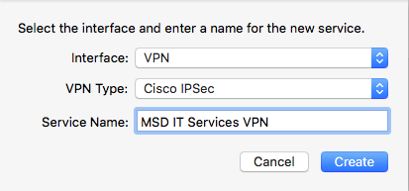
- You will now see the new service in your list of Network services (shown below as ‘MSD IT Services VPN Not Connected’):
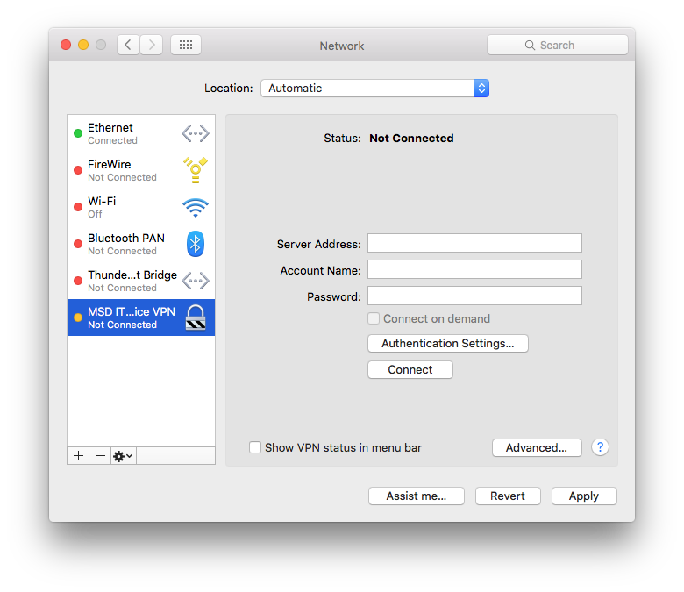

- It now needs to be configured for access. Click on the ‘Authentication Settings…’ button; you will see the screen below, in the ‘Shared Secret:’ box enter:
Medicine
- in the ‘Group Name:’ box enter:
MSD

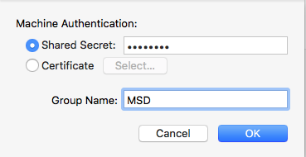
…then click ‘OK’

- Next make sure you enter:

vpn.medsci.ox.ac.uk
in the ‘Server Address:’ box

- You can also add your MSD IT Services Novell username; we would NOT recommend adding your password at this stage.

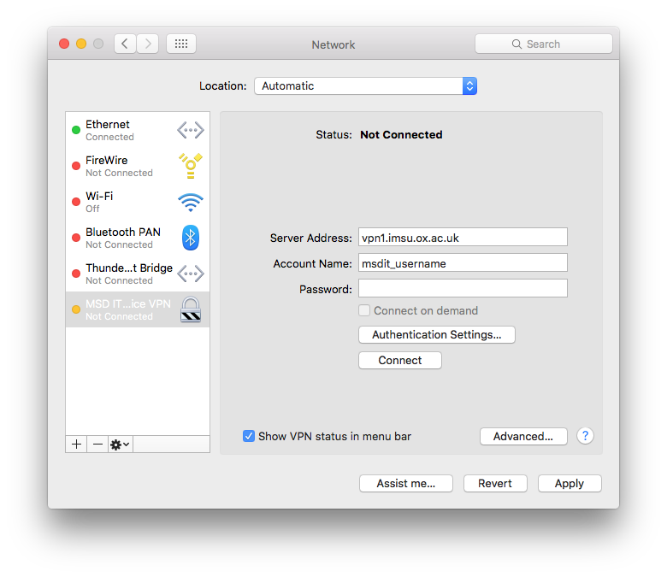

- Tick the box ‘Show VPN Status in menu bar’. Once all these changes are made click on the ‘Apply’ button to save them. You will now see a new icon in the Status Menu bar (near the top right) as shown below:

- You can use this to pull down the options menu to select ‘Connect’, once connected successfully a counter to the right of the icon may start counting up the connection time, if you have enabled this option.

Part B: Setting up the Remote Desktop software and connecting

  - Open ‘Remote Desktop Connection’ either from the Dock or via Go > Applications > Remote Desktop Connection, and in the ‘Computer:’ box type the IP address of your work PC (we will use ‘129.67.155.131’ as an example here) as shown below:
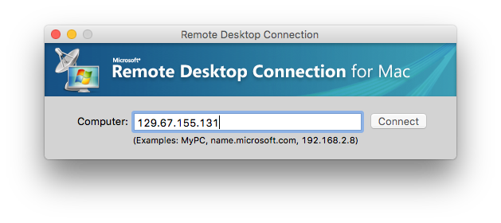
  - You will then be presented with another dialog:
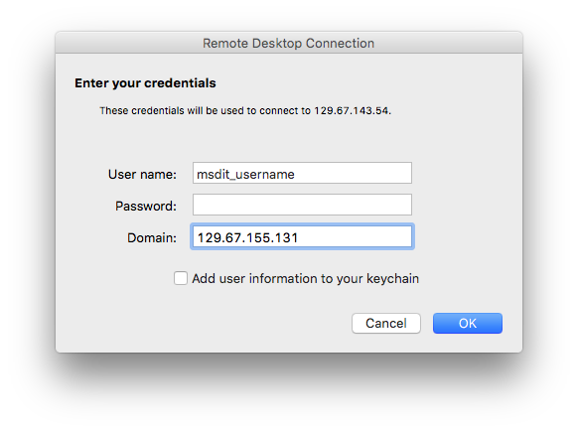
  - Enter your Novell User name and Password (leave the domain field blank) and click ‘OK.’

You should now have a Remote Connection to your work desktop:

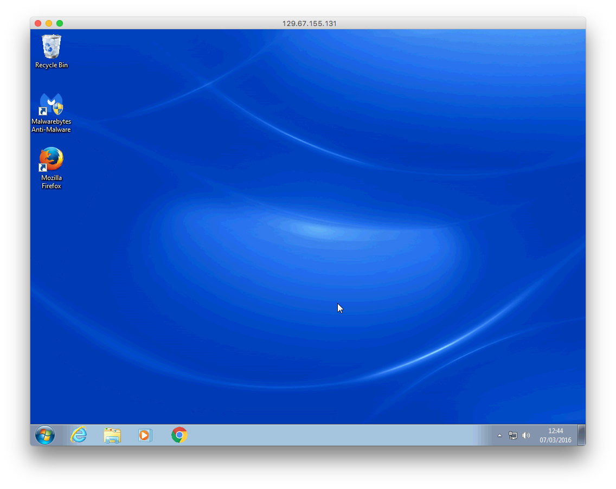

Part C: Disconnecting from your Work Desktop PC

- To disconnect the remote connection, simply close RDC.

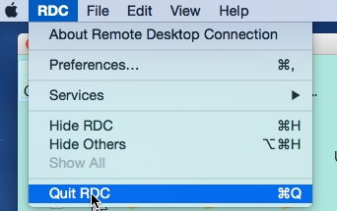
- Now click on the VPN icon in the Apple Menu and select ‘Disconnect’

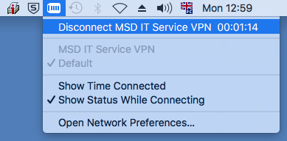

You are now disconnected from your Work PC.

4. Ubuntu 14.04 Home PC set up
This guide has been compiled using Ubuntu 14.04 ‘Trusty Tahr’; other flavours of Ubuntu (and indeed linux) may vary.
Ubuntu offers the opportunity to use an inbuilt (with a plugin installation) VPN Client or the Cisco AnyConnect VPN Client. We deliberately skirt the issue of installation of the AnyConnect Client here and recommend using the native VPN client on 64-bit Ubuntu - unless you find solving multiple dependency issues an enjoyable challenge.

Part A: Setting up the VPN software

Native VPN Client

- Firstly you need to install the native Ubuntu Cisco Compatible VPN ‘plugin.’ Go to the Ubuntu Software manager, type in vpnc and highlight ‘Cisco-compatible VPN Client’ and select ‘Install’

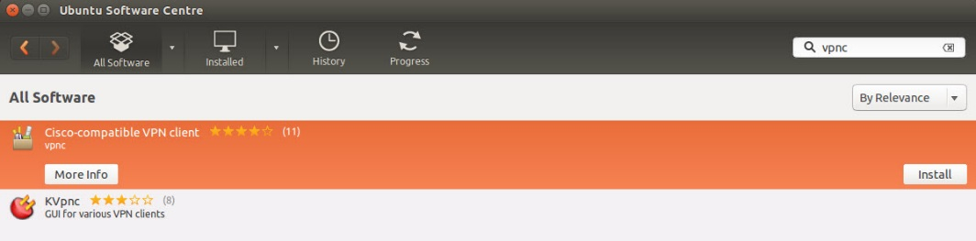
If you can’t find this in the Ubuntu Software manager, open a terminal and type
sudo apt-get install network-manager-vpnc
and press Enter. Provide your password when prompted and allow apt-get to install the necessary software.

- Once installed, go to the Network Manager near the top right hand corner (the icon) and select ‘VPN Connections’ then ‘Configure VPN’:

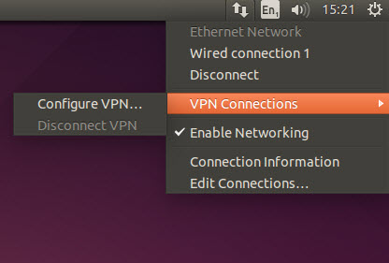
- Then from the Network Connection box click ‘Add’ and from the drop-down box scroll down to ‘Cisco Compatible VPN (vpnc)’ and select it:

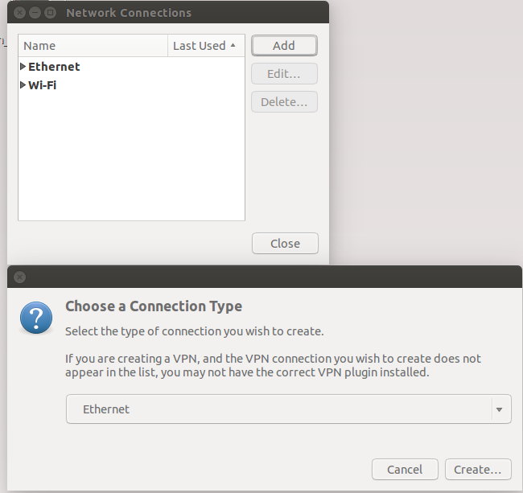
- Once selected click on the ‘Create’ button to configure the client:

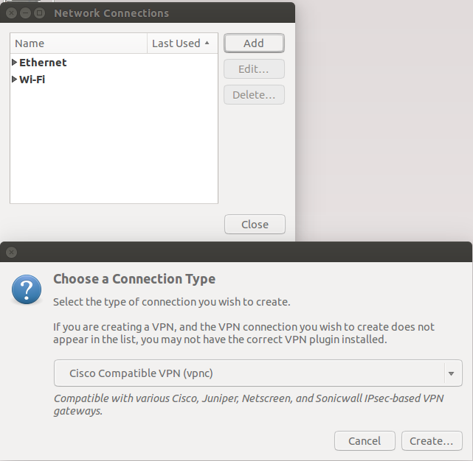

- In the Connection Name field enter something like ‘MSD ITS VPN’; for the other boxes:

Gateway: = vpn1.imsu.ox.ac.uk
User name: = Your MSD IT Novell username
User password: = Leave blank
(select ‘Always Ask’ from the menu options)
Group name: = MSD
Group password: = Medicine
(select ‘Save’ from the menu options)

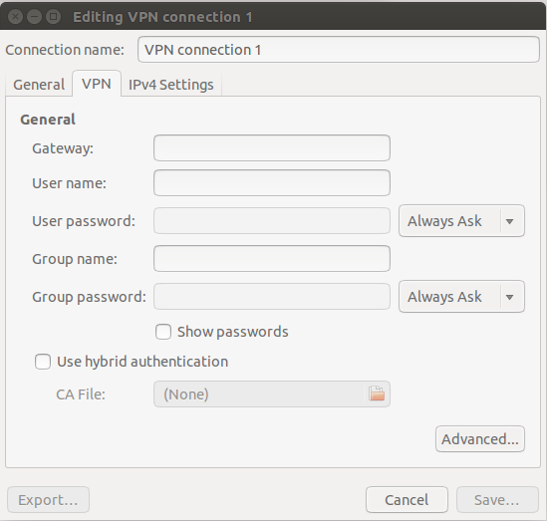
- Then click ‘Save’ and close all the windows

- To connect, select the VPN Service you created from the list in the Network Manager in the top right hand corner; you will be asked to enter your MSD ITS Network/Novell account password, as shown below:

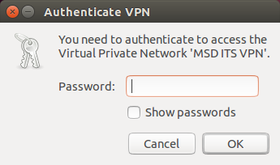

- Once this is done you should now have established a VPN connection to the MSD Network.

The Cisco AnyConnect Secure Mobility Client

- If you have not already done so, download and install the Cisco AnyConnect VPN Client from the University of Oxford IT Services Registration Pages at:

https://register.ox.ac.uk
Log in with your Single Sign On (SSO) username/password and select ‘Software’, then ‘VPN Client’ from the links provided. Download the ‘Client for Linux’ and install it; this client is preconfigured for use with the University of Oxford VPN Service but must use the MSD ITS VPN service for RDP sessions

- Once the Cisco AnyConnect VPN Software has been downloaded and installed, start the Cisco VPN Client from the Ubuntu Search Box:

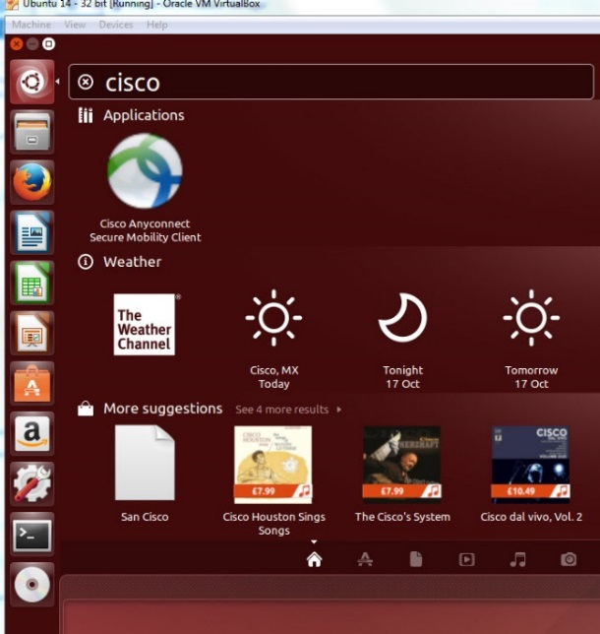

Hint: Right click on the Cisco Icon and select ‘Lock to Launcher’ for future use.

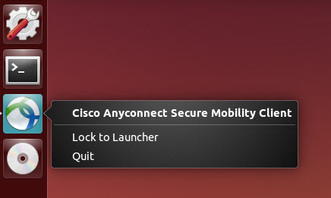

- Once started up, you can configure it as you would the Windows and Mac versions, as shown below:

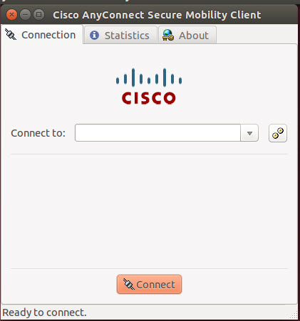

- Enter vpn1.imsu.ox.ac.uk in the ‘Connect to:’ box:

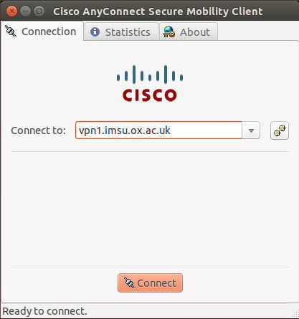
- Then enter your Remote Access Account username and password in the appropriate boxes and click ‘Connect’.

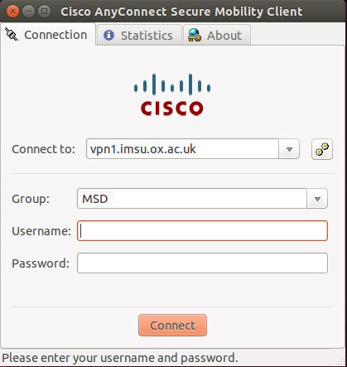
- Once a successful connection has been made, the client will minimise itself to the Launcher. To check your ‘Connection Status’, click on the ‘Cisco AnyConnect Secure Mobility Client’

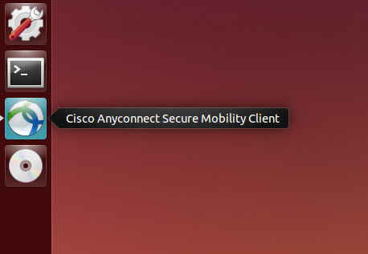
- You can then see the connection details as shown below:

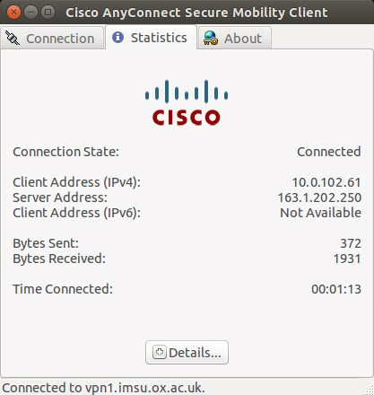

Part B: Setting up the Remote Desktop software and connecting

  - Install (if not already present) the Remote Desktop software called ‘Remmina’ - This can be done from the ‘Ubuntu Software Centre’

  - Once installed, from the Ubuntu Search box type:

Remmina
and click on the ‘Remmina Remote Desktop Client’ application icon:

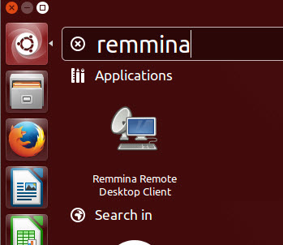
This will open Remmina in the Launcher
(Tip: Right Click on the Remmina icon and select ‘Lock to Launcher’ for later use)

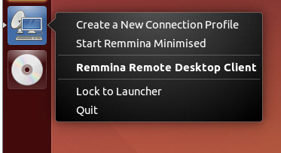
- Once Remmina is open on the desktop, click the ‘Create a new remote desktop file’ button (the icon with a green symbol):

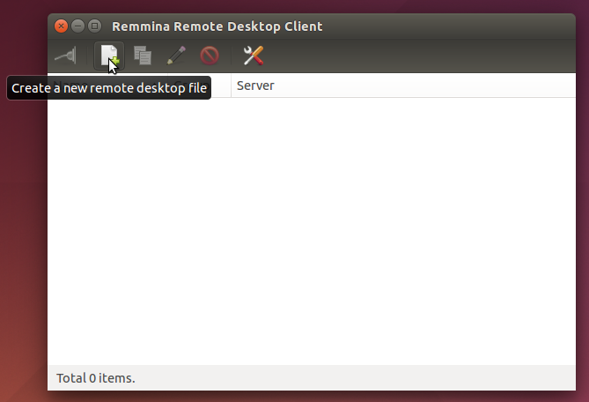
- On the ‘Basic’ tab:

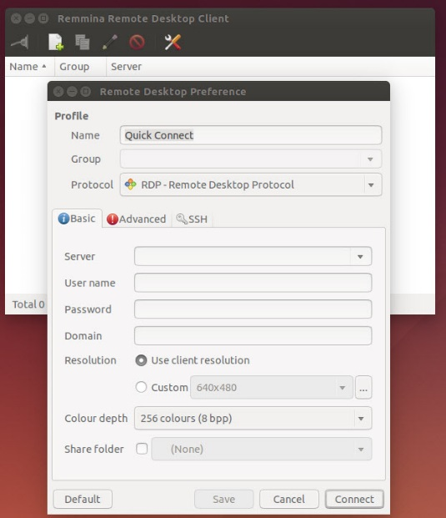
…give the Profile a name like ‘Work Desktop’ and fill in the fields as shown below:

Server: IP address of your Work PC
User name: Your MSD IT Network/Novell username

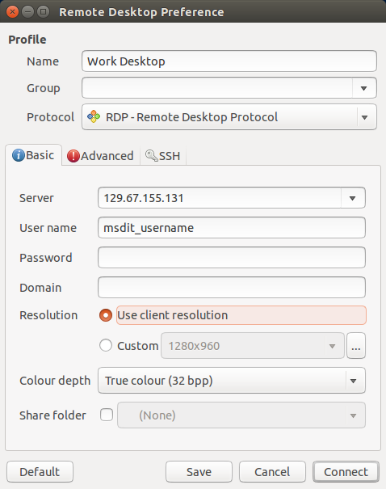

- In the ‘Advanced’ tab you can change the video Quality setting, from fastest to slowest as necessary:

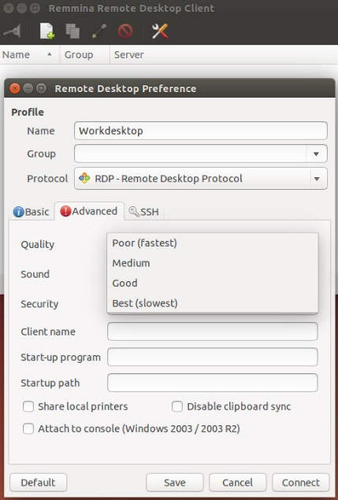
- Click on the ‘Connect’ button and enter your MSD IT Services Network/Novell Account password. The very first time you connect you will see a dialog similar to the one below:
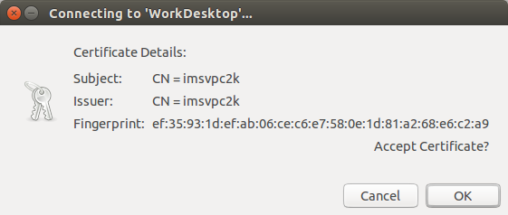
- Click OK

- If you left your username logged in to your work PC, you will then be presented with the following:

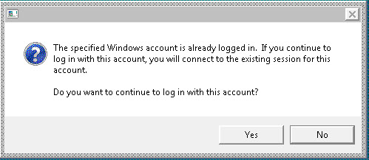

- Click ‘Yes’ and your Remote (Work PC) Desktop will be displayed.

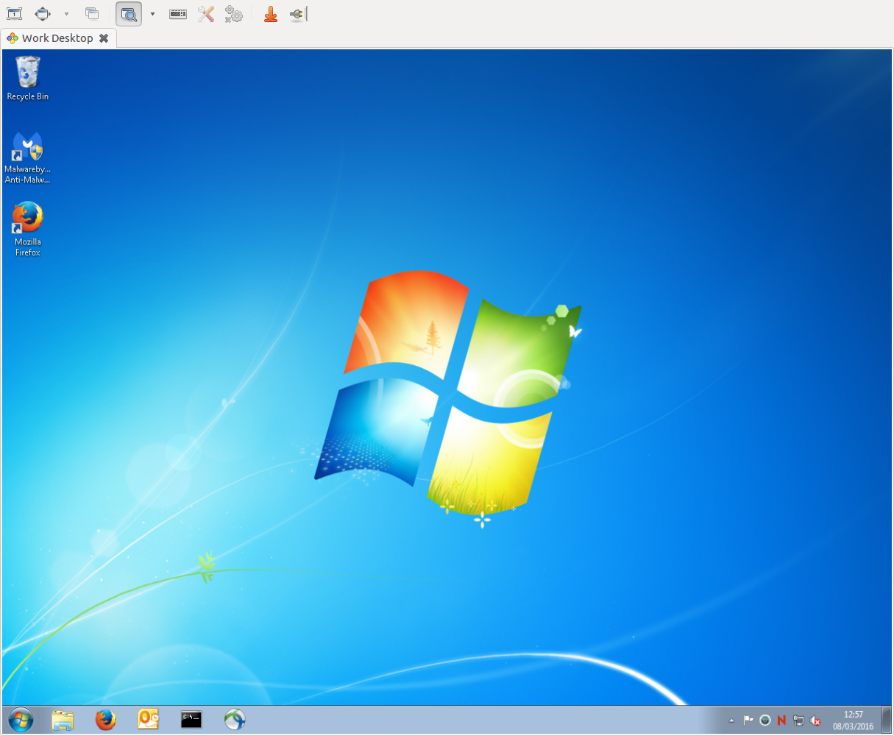

Part C: Disconnecting from your Work Desktop PC

- To disconnect simply click on the on the tab for the name you saved the connection as (in this case ‘Work Desktop’):

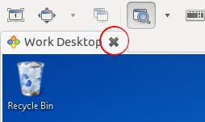

- Then disconnect the VPN Connection, either via the Network Manager > VPN Connections > Disconnect, or via the Cisco AnyConnect client, whichever was used.

The MSD IT Services Team.

