Remote login to the MSD IT network from a pre-configured Windows PC:

- Login to your remote computer via ‘Computer Only Login’, enable this by clicking on ‘Computer Only Login’ if your start up screen looks like this:
Ensure you type your network user name & password:
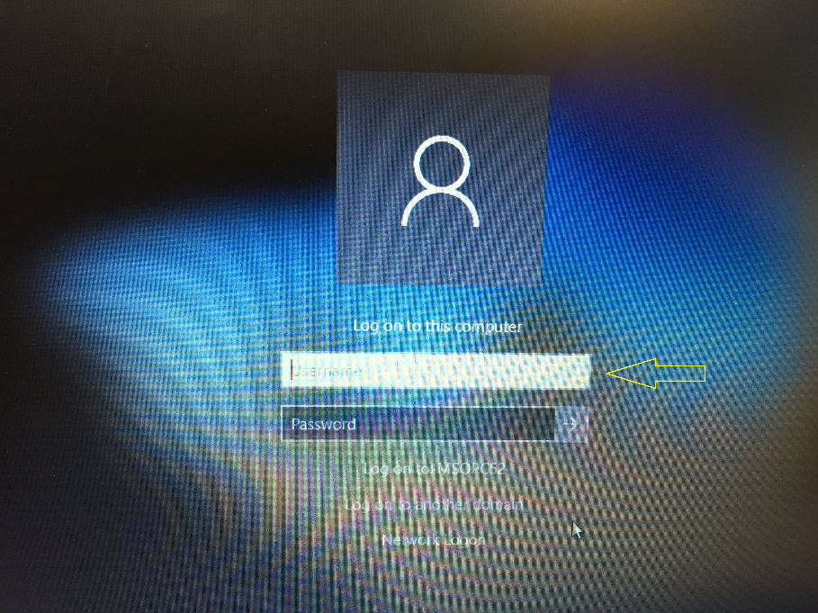
- Once you have logged in, ensure you have connected to your local network and then start a CISCO VPN connection:

If you have not already done so, download and install the Cisco AnyConnect VPN Client from the University of Oxford IT Services Registration Pages at:

https://register.ox.ac.uk
Log in with your Single Sign On (SSO) username/password and select ‘Software’, then ‘VPN Client’ from the links provided. Download the Windows 10 client and install it; this client is preconfigured for use with the University of Oxford VPN Service but you must use the MSD IT VPN service for RDP sessions.
- Once installed, start the Cisco AnyConnect VPN Client:

- 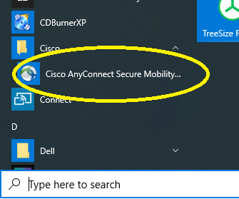

- Make sure the ‘Ready to connect’ box contains:

vpn.medsci.ox.ac.uk
…as shown:
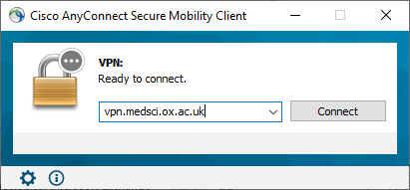
…then click on ‘Connect’.

- Following your first successful connection the login panel will look like this:
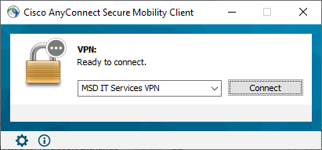
- There is no need to over type the address.

- Next enter your MSD IT network/OES/Novell account details in the ‘Username:’ and ‘ Password:’ boxes provided:

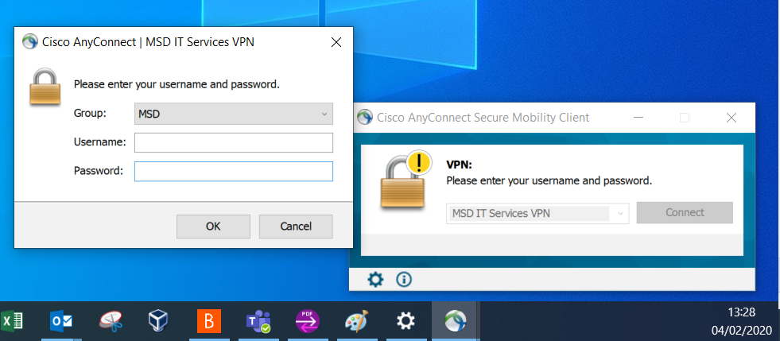
…then click ‘OK’
Once a successful connection has been made, the VPN Client will minimise itself to the System Tray (bottom right hand corner of the desktop.)

You can now log in to the MSD IT network:
  - If you see a large letter ‘N’ in the system tray:
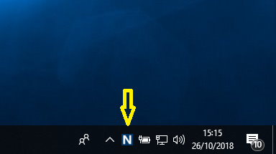

- If you don’t see the ‘N’ in the system tray, click on the caret/^ symbol

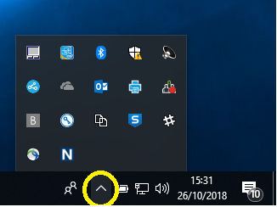

- Then right click-on the ‘N’ & click on ‘OES Login…’

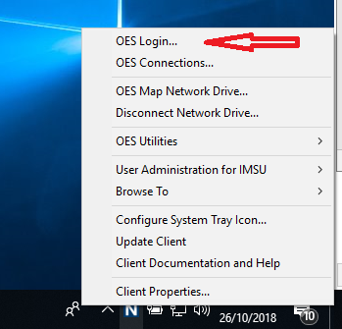
- This will pop up a network login windows, enter your MSD IT network user name & password:

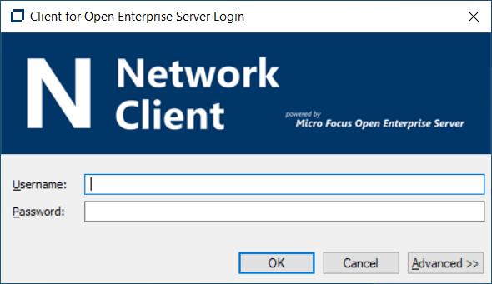

- You can then log in to see your network drive:

