
MEDICAL SCIENCES DIVISON
RAISING AWARENESS:
MODELS OF DISEASE

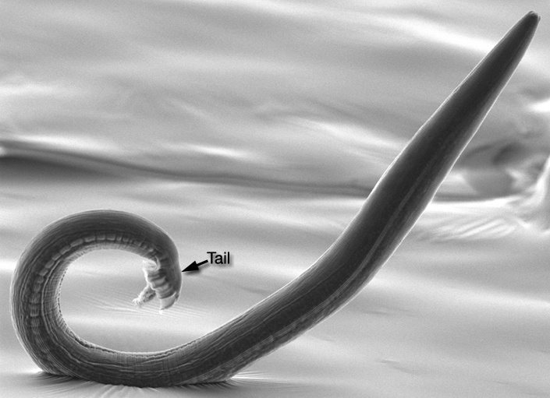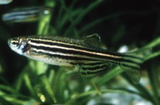
C.elegans Zebra Fish
WHEN: Thursday 25th March 2010
WHERE: Science Area, South Parks Rd
TIME: 9am – 3.30pm (lunch provided)
SPEAKERS: Prof F Ashcroft, Dr S Totterdell, Dr P Hawkins, Prof R Patient, Prof J Hodgkin, Dr A Russ, Dr R Deacon & Dr P Oliver.
-----------------------------------------------------------------------------
All research students and staff within the Medical Sciences Division are invited to attend.
For the event programme and to register visit - http://www.medsci.ox.ac.uk/skillstraining

RAISING AWARENESS: MODELS OF DISEASE
Thursday 25th March 2010 in the Science Area
Please register to attend online at http://www.medsci.ox.ac.uk/skillstraining

PROGRAMME
9.00am | Coffee and Registration.
9.30am | Welcome -
9.40am | Dr Robert Deacon – Experimental Psychology ‘Assessment of Rodent Behavioural Phenotypes’
10.10am | Dr Sue Totterdell – Pharmacology ‘Modelling Madness’
10.40am | Dr Peter Oliver – Physiology, Anatomy & Genetics ‘Neurodegeneration’
11.10am | TEA BREAK
11.30am | Professor Roger Patient – WIMM ‘Insights into Adult Stem Cell Development from Xenopus and Zebrafish’
12.00pm | Professor Jonathan Hodgkin – Biochemistry ‘Genetics of Nematode Immunity and Development’
12.30pm | Dr Penny Hawkins – RSPCA ‘Ethical Issues and the Three Rs’
1.00pm | LUNCH
2.00pm | Dr Andreas Russ – Biochemistry ‘Orphan Genes: New Physiology, New Drug Targets’
2.30pm | Professor Frances Ashcroft – Physiology, Anatomy & Genetics ‘Mouse Models of Diabetes’
3.00pm | Closing Remarks

