MRC Discovery Award 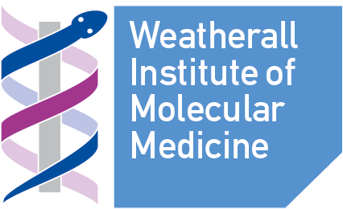

Application form

Applicant details
Name
University Department
Telephone
Email

Co-Applicant(s) details (add extra lines if needed)
Name
Contact details (email and phone number)
University Department

Project details
Title
Start date of project
End date of project
Total cost of Project
(Direct costs only)
Project Summary (300 words maximum):

Statement (maximum 3 pages of A4 – Arial 11 point, including references and figures):
Please describe the project and how the project meets the aims of the MRC Discovery Award

Financial details:
Please provide a breakdown of the funds requested

Additional supporting material
Curriculum Vitae (max. 1 side A4 per CV)

List of publications (List up to 5 relevant publications to support this application)

Departmental administrative contact
Name and contact details
Departmental code
Signature
NB: Any award will only cover direct research costs

