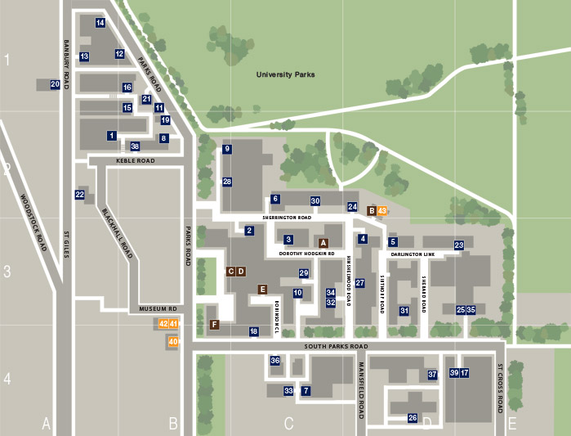
23: Medical Sciences Teaching Centre

